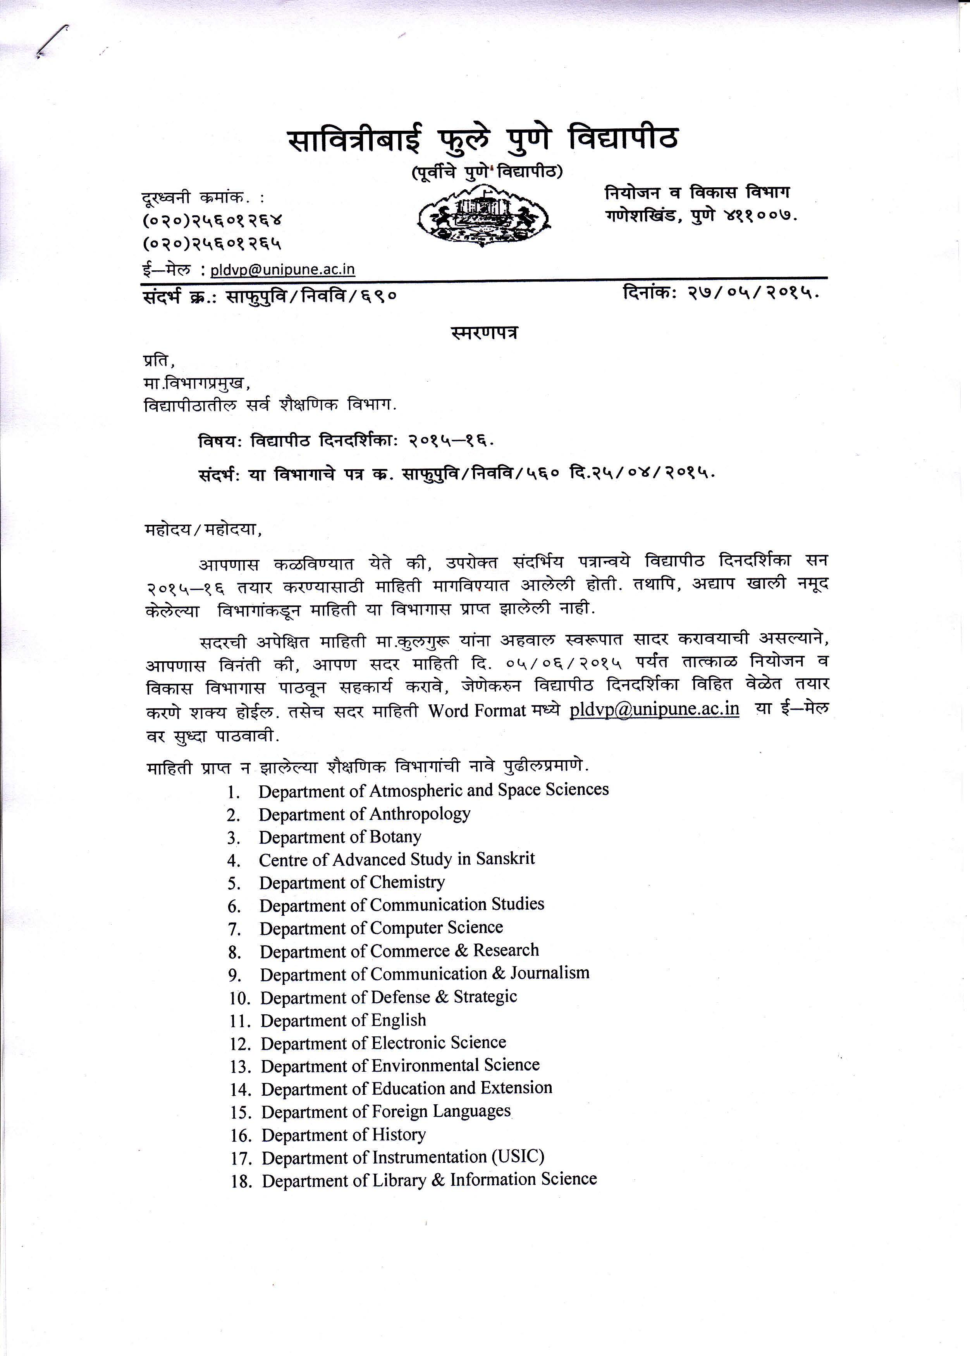
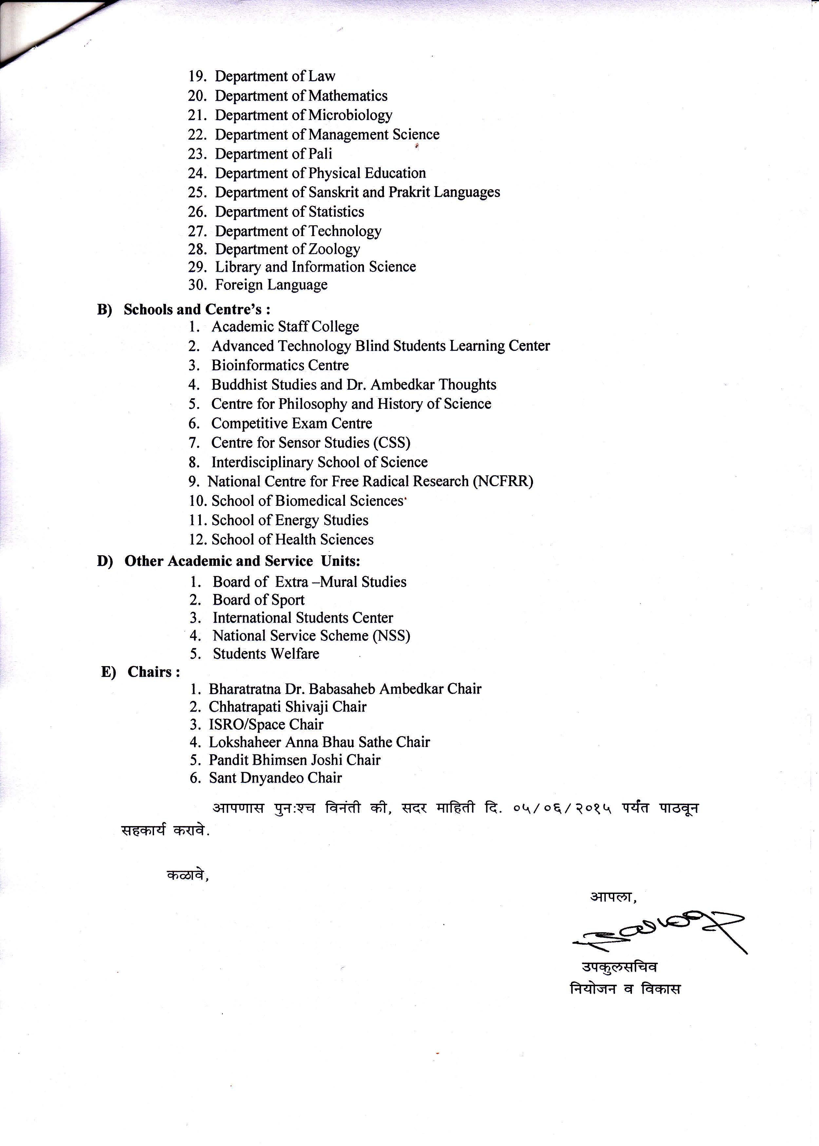

Name of the Department/Centre------------------------------
Savitribai Phule pune UNIVERSITY

University CALENDAR
2015-2016

Part A: University & Administrative Departments

Part B: Examination Section

UNIVERSITY CALENDER 2015-16
PART – A
UNIVERSITY & ADMENISTRATIVE DEPARTMENTS
SAVITRIBAI PHULE PUNE UNIVERSITY June 2015

UNIVERSITY CALENDAR : 2015-16
1st week
1.6.15 to 6.6.15
2nd week
8.6.15 to 13.6.15
3rd week
15.6.15 to 20.6.15
4th week
22.6.15 to 27.6.15
5th week
29.6.15 to 30.6.15

SAVITRIBAI PHULE PUNE UNIVERSITY July 2015

UNIVERSITY CALENDAR : 2015-16
1st week
1.7.15 to 4.7.15
2nd week
6.7.15 to 11.7.15
3rd week  13.7.15 to 18.7.15 | 18.7.2015 Ramzan Id Holiday
4th week
20.7.15 to 25.7.15
5th week
27.7.15 to 31.7.15
SAVITRIBAI PHULE PUNE UNIVERSITY August 2015

UNIVERSITY CALENDAR : 2015-16
1st week
1.8.15 to 8.8.15
2nd week  10.8.15 to 15.8.15 | 15.08.2015 Independence day Holiday
3rd week  17.8.15 to 22.8.15 | 18.08.2015 Parsi New Year Holiday
4th week  24.8.15 to 31.8.15 | 29.08.2015 Rakshabandhan Holiday & 30.08.2015 SUNDAY

SAVITRIBAI PHULE PUNE UNIVERSITY September 2015

UNIVERSITY CALENDAR : 2015-16
1st week
1.9.15 to 5.9.15
2nd week
7.9.15 to 12.9.15
3rd week  14.9.15to 19.9.15 | 17.09.2015 Ganesh Chaturthi Holiday
4th week  21.9.15 to 26.9.15 | 25.09.2015 Bakri Id Holiday
5th week
28.9.15 to 30.9.15

SAVITRIBAI PHULE PUNE UNIVERSITY October 2015

UNIVERSITY CALENDAR : 2015-16
1st week  1.10.15 to 3.10.15 | 2.10.2015 Mahatma Gandhi Jayanti Holiday
2nd week
5.10.15 to 10.10.15
3rd week
12.10.15 to 17.10.15
4th week  19.10.15 to 24.10.15 | 22.10.2015 Dussehra & 24.1.2015 Muharram Holiday
5th week
26.10.15 to 31.10.15

SAVITRIBAI PHULE PUNE UNIVERSITY November 2015

UNIVERSITY CALENDAR : 2015-16
1st week
2.11.15 to 7.11.15
2nd week  9.11.15 to 14.11.15 | 11.11.2015 To 13.11.2015 Diwali Holiday
3rd week
16.11.15 to 21.11.15
4th week  23.11.15 to 30.11.15 | 25.11.2015 Guru Nanak Jayanti Holiday & 29.11.2015 SUNDAY HOLIDAY

SAVITRIBAI PHULE PUNE UNIVERSITY December 2015

UNIVERSITY CALENDAR : 2015-16
1st week
1.12.15 to 5.12.15
2nd week  7.12.15 to 12.12.15 | 7.12.2015 Kartik Ekadashee Holiday
3rd week
14.12.15 to 19.12.15
4th week  21.12.15 to 26.12.15 | 24.12.2015 Id-A-Milad Holiday & 25.12.2015 Christmas Day Holiday
5th week
28.12.15 to 31.12.15

SAVITRIBAI PHULE PUNE UNIVERSITY January 2016

UNIVERSITY CALENDAR : 2015-16
1st week
1.1.16 to 2.1.16
2nd week
4.1.16 to 09.1.16
3rd week
11.1.16 to16.1.16
4th week
18.1.16 to 23.1.16
5th week  25.1.16 to 30.1.16 | 26.01.2016 Republic Day Holiday

SAVITRIBAI PHULE PUNE UNIVERSITY February 2016

UNIVERSITY CALENDAR : 2015-16
1st week
1.2.16 to 6.2.16
2nd week  8.2.16 to 13.2.16 | 10.02.2016 Savitribai Phule Pune University Foundation Day
3rd week
15.2.16 to 20.2.16
4th week  22.2.16 to 29.2.16 | 28.02.2016 SUNDAY

SAVITRIBAI PHULE PUNE UNIVERSITY March 2016

UNIVERSITY CALENDAR : 2015-16
1st week
1.3.16 to 5.3.16
2nd week  7.3.16 to 12.3.16 | 7.03.2016 Mahashivratri Holiday
3rd week
14.3.16 to 19.3.16
4th week  21.3.16 to 26.3.16 | 25.03.2016 Good Friday & 26.03.2016 Shivaji Maharaj Jayanti Holiday
5th week
28.3.16 to 31.3.16

SAVITRIBAI PHULE PUNE UNIVERSITY April 2016

UNIVERSITY CALENDAR : 2015-16
1st week
1.4.16 to 2.4.16
2nd week  4.4.16 to 9.4.16 | 8.04.2016 Gudi Padwa Holiday
3rd week  11.4.16 to 16.4.16 | 14.04.2016 Dr. Babasaheb Ambedkar Jayanti & 15.04.2016 Ramnavami Holiday
4th week  18.4.16 to 23.4.16 | 19.04.2016 Mahavir Jayanti Holiday
5th week
25.4.16 to 30.4.16

SAVITRIBAI PHULE PUNE UNIVERSITY May 2016

UNIVERSITY CALENDAR : 2015-16
1st week
2.5.16 to 7.5.16
2nd week
9.5.16 to 14.5.16
3rd week  16.5.16 to 21.5.16 | 21.05.2016 Buddha Purnima Holiday
4th week
23.5.16 to 28.5.16
5th week
30.5.16 to 31.5.16

- Dates of University Management Council/Senate Metting are tentative. These dates may change as per the decision of University Authority.
- Management Council meeting will be held one in each month.

Signature of the Head
Note: Departments are expected to furnish the information on following aspect in the chart given above.

- Admission programme
- Commencement and conclusion of every term
- Number of teaching days
- Seminars, Conferences, Workshops
- Lecture Series
- Invited/Guest Lectures
- Important events like Science Day, Moot Court Competition and Quiz Debates etc.
- Students related activities like Sports, Day, Extra Curricular and Cultural events etc.

